31.13: a)
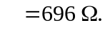
b) 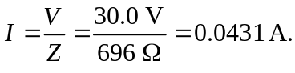
c) 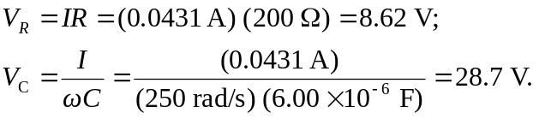
d) 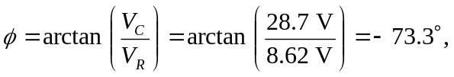 and the voltage lags the current.

e)

